Close & Settle a Repair Order in ROM – Pay with Credit Card: This topic covers how to close and settle a repair order in ROM when paying with a credit card.

Access an Existing Repair Order:

- Press the button.
- Type in the Repair Order # or press the arrow to look it up.
- Press “Enter” or “Tab” to accept the repair order.

Click on Condition 001 to expand the window.

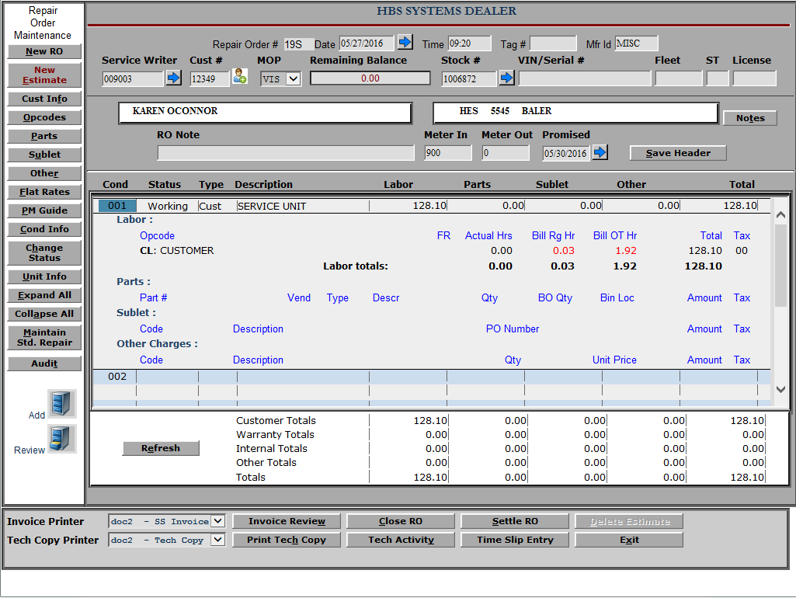

Review Labor: Click on Hours under Bill Rg Hr. A pop-up window of all time slips on this RO/Condition/Opcode appears.

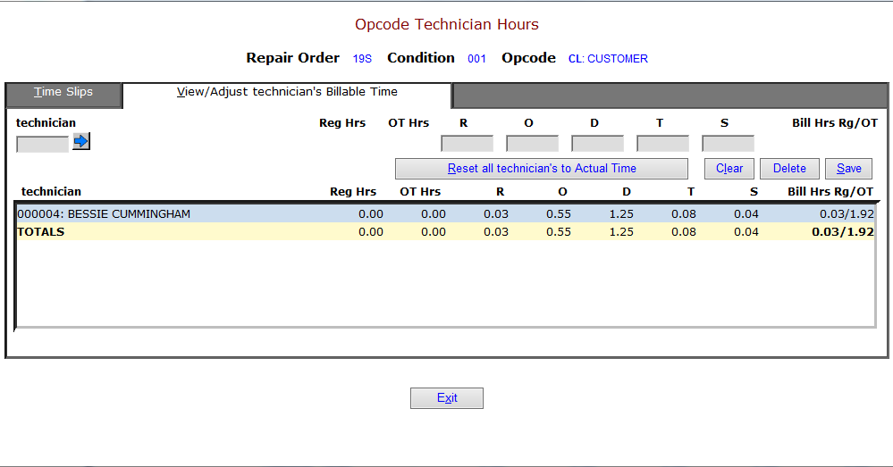

Time Slip Tab: View all times slips by tech.

View/Adjust Technicians Billable Time Tab: Click on a Tech to change billed hours as needed (Reg, O/T, Double, Triple, etc.).

When finished, click Save and Exit.

Invoice Review: Preview the invoice prior to printing (see below for sample invoice).

- Select the “see” printer to display your invoice with totals to the screen.
- Select a printer to get a printout.

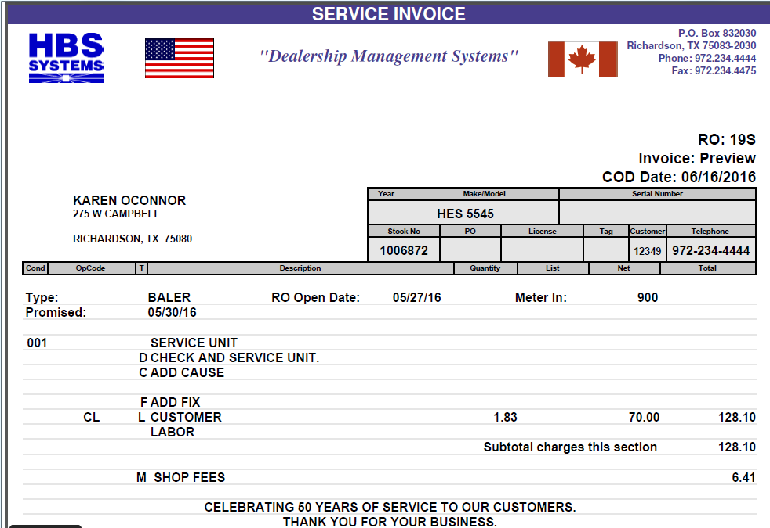

Settle the RO: Click on the Settle RO button.

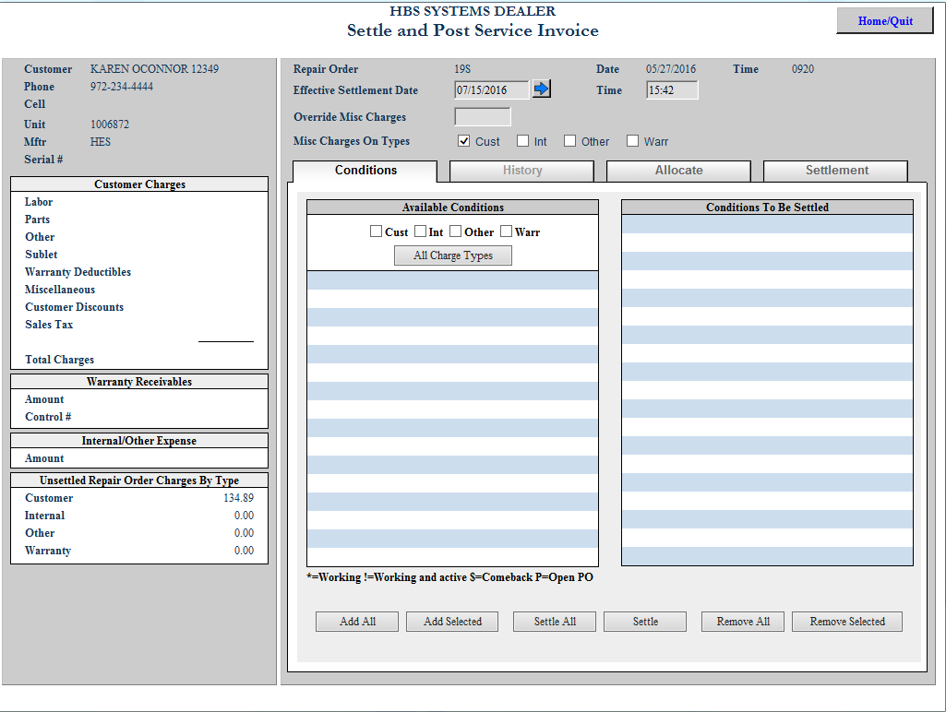

- Click on the All Charge Types button in the center of the screen.
- Click on the Settle All button at the bottom of the screen. You will be moved to the Settlement tab (see below).
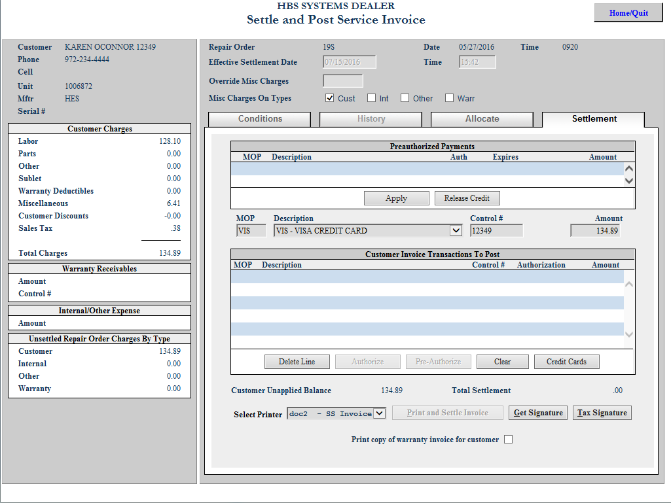

- Press “Enter” or “Tab” through the Control Number and Amount fields on the Credit Card Payment line. This will open EdgePay Input, HBS NetView’s credit card payment processing program.
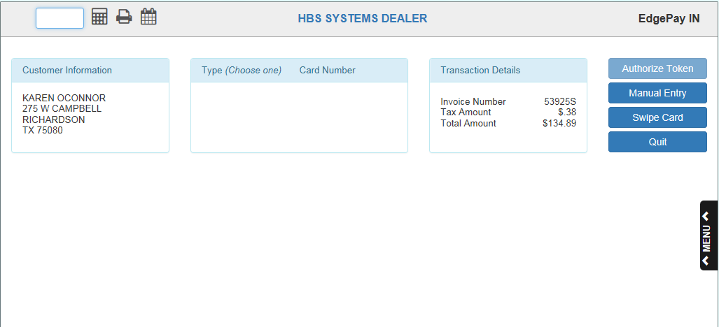

- Enter the credit card for payment by one of the following methods:
  - If the card is already entered into the system, select the card from the list on the screen.
  - Otherwise, swipe the credit card, or enter the card number and expiration date to record the card in the system.
- Proceed with the transaction.
  - If the credit card communications package is installed, you will receive messages about the progress of the authorization.
  - If not, you will fill in the authorization number from your manual credit card machine.
- After the transaction successfully completes, return to the invoice payment screen.
- Press the Print and Settle button on the bottom of the screen.
- Check your invoice and press Yes to say it printed ok. At this point, the process will be complete.

